Suji Shin

November 20, 2018

TP1

**TP1 Part 1: Project Proposal**

**Project Description [5 pts]**

Title: The Immune System

Description:

For the term project, I will be creating an interactive, educational game on the immune response, which is the body’s response caused by its immune system being activated by antigens on pathogenic invaders. Our immune system is composed of many different types of immune cells and different types of immune responses, which act as subsequent lines of defense. General mechanism and immune cells interactions of Innate and Adaptive immune responses to bacterial infection will be illustrated. A user will be able to navigate through different steps of the immune responses with different types of immune cells that interact with each other to fight off a bacterial infection. in addition, the user will be able to learn how innate immune response bridges adaptive immune response through the game. The end goal of the game is to prevent pathogenic invader, or bacteria, from destroying our cells.

**Competitive Analysis [5 pts]:**

1. *Immune System Game* (Author: Critter2002)

-Source: https://www.newgrounds.com/portal/view/478787

* This project was created by a user named Critter2002 on NewGrounds.com. The author made the project features three educational mini-game based on the immune system in the human body.
  + Game 1: Three Lines of Defence
    - A geometry wars type shooting game. It is set inside the human body where T-cells must defend the body against invading pathogens.
  + Game 2: Drag and Drop
    - A timed quiz, where the user must correctly sort diseases into contagious and non-contagious categories.
  + Game 3: The Black Plague
    - A maze type game where the use must navigate a villager through a village infected with the plague.

2. *Conflict: Immunity* (Author: BioMan Biology)

-Source: https://biomanbio.com/HTML5GamesandLabs/Physiogames/conflictimmunityhtml5page.html

* The game was created by BioMan Biology, a website dedicated for learning Biology through games, review games, etc. It employs a simple model of a type of immune response. The objective is to use different types of immune cell, such as macrophage, Helper T-cell, B-cell, Killer T-cell, and memory cell, to fight against bacteria.

3. *The Immune System* (Author: Science Learning Hub)

-Source: https://www.sciencelearn.org.nz/embeds/13-the-immune-system

* Unlike the other two games mentioned above, The Immune System is an interactive learning module that layouts the immune system in animation.

|  |  |  |  |  |  |
| --- | --- | --- | --- | --- | --- |
|  | **Dimension 1** | **Dimension 2** | **Dimension 3** | **Dimension 4** | **Dimension 5** |
| ***1. Immune System Game*** | The first part of the game that involves immune system is set inside the human body where T-cells must defend against invading pathogens. The objective is to shoot pathogens with using T-cells, along with antibodies and B-cells. The player can change ammunition type to different types of B-cells that corresponds to the matching pathogen. | Before the start of the game, a player must answer a short fill-in-the-blank questionnaire. It is succinct and describes the immune system clearly to help play the game more easily. The fill-in-the-blank page also includes “instructions”, “main menu”, and “play” options for users. | This game is composed of three parts and only a fraction of the immune system is represented and it is more like an entertainment game, rather than an educational game as it advertises. | Quiz mode is not comprehensive enough as an educational game. It only includes four questions, which are not particularly interesting or help educate the player about the immune system. | The game contains the third part, which is similar to Pacman, where the player must run through the maze to navigate through a village infected with a black plague. I thought this was unnecessary and didn’t see how this could be an educational game. |
| ***2. Conflict: Immunity*** | Able to choose different immune cell types to interact with bacteria in a cascade manner | Help Mode: Legend of different immune cell types that users can refer to. Each immune cell’s function and description are included. | During quiz mode, B plasma cell icon can be moved using arrow keys to select the correct answer | The first part of the game is the tutorial mode, which allows the user to easily learn how to play the game. | Includes a feature to turn on or off background music |
| ***3. The Immune System*** | Includes intricate diagram showing each parts of the body involved in the immune response, which allows users to follow the material more easily. | Although it is not an interactive game, anyone who is interested in learning about the immune system can easily use this to learn. Descriptions are detailed and accompanied animations/graphics allow the user to comprehend more easily. | One of the mode “Immune System” graphically shows different types of immune cells and foreign invaders. Any type of cell can be clicked for description of the cell and its function. Cells are divided into three groups, each indicating different location each cell is found within the body, such as inside lymph vessel and inside blood vessel. | Total four modes users can choose: Introduction, Immune System, Virus Immune Response, and Bacteria Immune Response. Each mode explains the mechanism, involved cell types, and descriptions, using animation and narration. | The game is semi-interactive. The user can choose which mode to view, but each view is only consisted of animation illustrating what is happening in each mode. |

After comparing three projects that focus on immune system education, there are certain features that my project should include to be more competitive. First, the project should focus on the general mechanism of the immune system, including innate and adaptive and how they are bridged together. Some of the competitions are either too game-focused or animation-focused without interaction. Instead of focusing on one aspect, the goal is to create a project that educates users on the comprehensive general overview of the immune system in a more interactive, game-style approach.

*Conflict: Immunity* includes a help mode that illustrates the immune cells involved in the game and their descriptions and functions. It is extremely helpful to have a separate legend that describes different types of cells involved in the immune response. A similar attribute can be added to the project so users can learn about the cells before proceeding to play the game. In addition, although *Conflict: Immunity* is not the most comprehensive game that is designed as educational purpose, the flow of the game naturally allows users to learn about the sequence of the immune response, by letting users to switch between types of immune cells that react or signal with specific cells or bacteria in a sequence.

**Structural Plan [5 pts]**

1. Classes

Object Bacteria

attribute name

function die

function shrink

Object Phagocytes

attribute name

function killBacteria

Object Macrophage inherits from Phsagocytes

attribute presentAntigen

Object DendriticCell inherits from Phagocytes

function presentAntigen

function activateAdaptiveImmunity

Object helperTCell

Attribute name

function activateBnKT

Object killerTCell

attribute name

function recognizeAntigen

function secretePerforin

function collidesWithBacteria

Object bCell

attribute name

function makeMemory

function makePlasma

Object bMemoryCell inherits from bCell

function storeForFuture

Object bPlasmaCell inherits from bCell

function produceAntibody

function antibodyKillBacteria

2. Animation

function recognizeAntigen

function engulfByPhagocyte

function bCellDevelopment with MousePressed

function activateTCell

function KTCellKills

**Algorithmic Plan [5 pts]**

First: Generate immune cells classes

* Write class & subclass objects for each immune cell
* Import images drawn on Wacom Tablet for each immune cell file

Second: HELP! (Stage 0 – Start screen)

* Start screen with tutorial that contains short descriptions/images of:
  + Introduction to immune system
  + Immune cell types involved
  + Innate immune system
  + Adaptive immune system

Third: Innate Immune System (Stage 1 – Infection Site)

* Start with a set number of bacteria (e.g. 20 bacteria)
* Phagocytes (Macrophage) is attracted to bacteria and engulf and digest bacteria
* Dendritic cells engulf and digest bacteria and present antigen on the surface
* Some bacteria break the 1st line of defense 🡪 keep count of alive bacteria

Fourth: Adaptive Immune System (Stage 2 – Lymph Node)

* Dendritic cells (with antigen) migrate to lymph node (visualization)
  + Antigen on DC activate T-cells
* Activated T-cells replicate
  + When Killer T-cells recognize antigen on bacteria, they destroy bacteria
    - Secrete perforin that makes holes in the infected cell’s membrane.
    - Perforin be represented as small dots around T-cells
  + Helper T-cells (secrete cytokines to) activate B-cells and Killer T-cells
* B-cell replicates & matures into:
  + Plasma cell 🡪 leaves the lymph node
  + Memory cell 🡪 stay in the lymph node

Fifth: Adaptive Immune System Continues (Stage 3 – Infection Site)

* Activated T- and B-cells leave lymph node and migrate to the infection site.
* Plasma cells release antibodies
* Antibodies attach onto bacteria surface to disable & flag for destruction
* Macrophages attracted and engulf & digest bacteria
  + Check if Killer T-cell destroy remaining bacteria

Sixth: Infection Healed or Not? (Stage 4 – End stage)

* If no bacteria left, infection has been healed!
* If some bacteria are left, show Try Again screen

**Timeline Plan [5 pts]**

*November 20 - TP1 Due

November 22 – Thanksgiving

November 23 – Finish coding class objects (Immune cells)

November 25 – Start coding the innate and adaptive immune system functions

November 26 – Finish coding the innate and adaptive immune system functions

November 27 – Complete the writing portion of TP2 deliverable, if necessary. Otherwise, review

the working demo for any possible error/bugs/missing features.

*November 28 – TP2 Due

December 2 – Finish the project code part

December 3 – Start/Finish the writing portion of TP3 deliverable

December 4 – Film the video demo

December 5 – Final review of the project

*December 6 – TP3 Due

**Version Control Plan [3 pts]**

I will be using Google Drive provided by CMU as the version control plan. I created a folder designated for 15-112 Term project. Under the folder, I created a mock file with a new version uploaded to keep track of updated versions of the file. The picture included below shows how I will be managing different versions and organizing files and documents needed for the project.

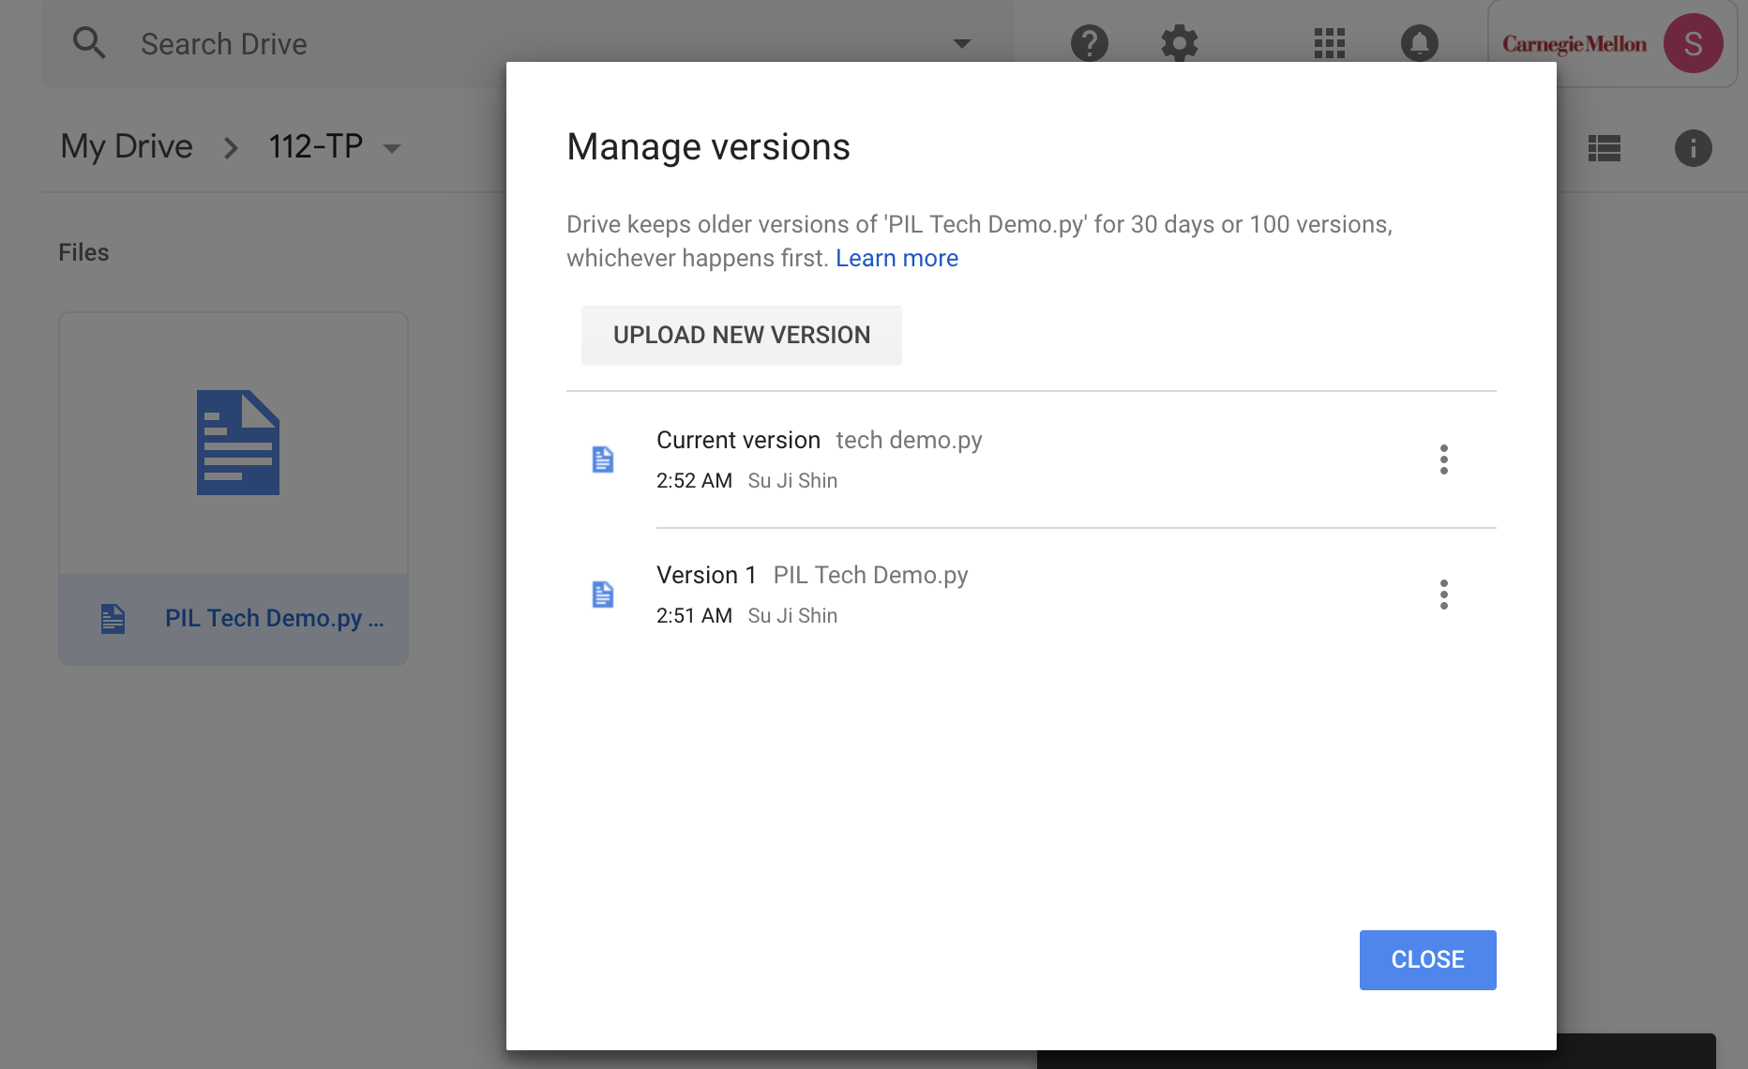

**Module List [2 pts]**

The module I will be using for the project is Python Imaging Library (PIL).